WEEKLY LESSON PLAN
WEEK 8
SUBJECT: OWOP |  | Day: MONDAY |  | Strand: MY FAMILY
 |  |  |  | Sub Strand: MY SCHOOL FAMILY
Class: KG 2 |  | Class Size:
Content Standard:  K2.2.4 .1 Demonstrate understanding of the rules and regulations for learners and teachers at school. |  |  | Indicator:  K2.2.4.1.1 Talk about and discuss the rules and regulations that guide us to live as good friends in the school family
Performance Indicator:  - Learners can talk about and discuss the rules and regulations in the school. |  |  |  | Core Competencies:  Communication and collaboration, Critical thinking, Personal Development and Leadership
Keywords:
Phase/Duration | Learners Activities |  |  |  | Resources
PHASE 1: STARTER | Have learners to sing songs and recite rhymes that relate to the lesson.  LETS ALL DO (tune of we wish you a merry Christmas)  Let’s all do a little clapping,  Let’s all do a little clapping,  Let’s all do a little clapping,  And spread Christmas cheer.  (Continue with actions like jumping, twirling, stretching etc.)
PHASE 2: NEW LEARNING  CIRCLE TIME | Engage learners in the community circle time.  Place chairs in a line or in a circle facing out.  Lead children (more than the number of chairs available) around the chairs while singing a song.  At the end of the song, each child must sit down in the chair by which he or she is standing.  The child who remains standing is out of the game.  The last person to remain siting is the winner.  Repeat the game as long as the children are having fun
GROUP ACTIVITY 1  (OUTDOOR) | Display three conversational posters (In the classroom, At the library, friendship) all related to the theme, and engage learners in active discussion on what they see in the pictures.  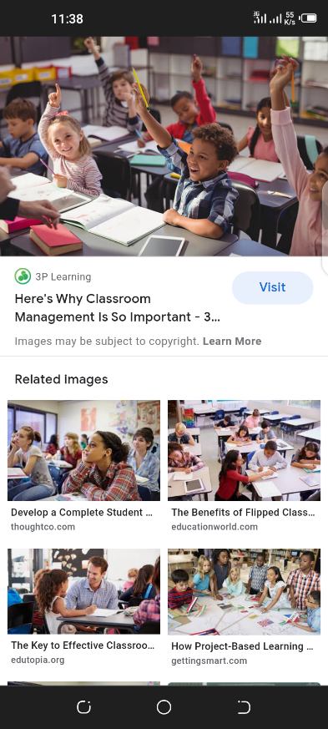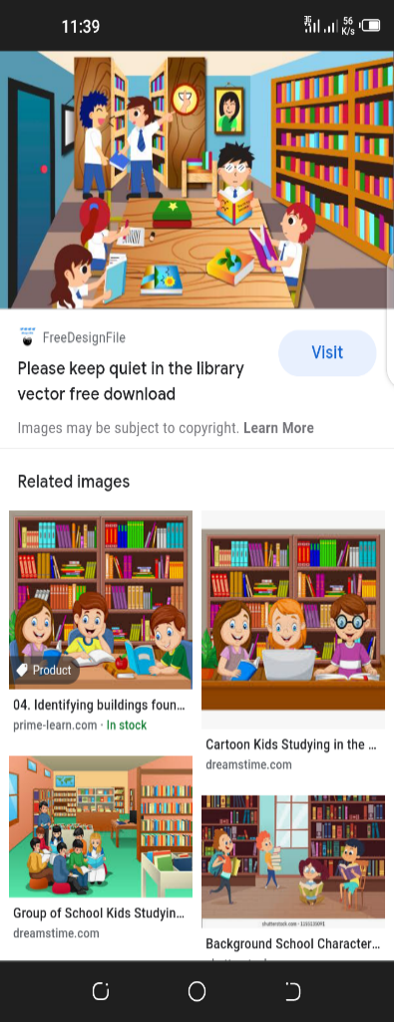  Talk about the members of the school family, e.g. The head, teachers and classmates, and the rules that governs us to live at peace with each other in the classroom and the school as good friends and family members.  Learners through the observation of the conversational poster come up with simple rules to help them become law abiding and respectful learners in the school.  Sit the children in a circle, facing inwards.  One child is chosen to be “it”. it walks around the circle, gently tapping each other player in turn on the head or shoulder, naming each player as a ‘Duck’.  When ready, it chooses one player to be the ‘Goose’ – tapping that player on the head and shout ‘Goose’.  The player selected as Goose stands up and chase It around the circle, trying to tap her before she gets all the way around the circle to sit back in the spot where the Goose was originally sitting.  If the Goose is not able to tag the It, then Goose becomes It and the game continues.  RCA QUESTION  - Who makes rules for the school?  - Who makes rules at home?  - What happens to people who break laws? |  |  |  | Poster/ cut out picture depicting school/classroom gathering e.g worship, our day, Cut out shapes, big books, counters, crayons
PHONICS | Engage learners to sing songs and recite some familiar rhymes that relates to the target sound.  Guide learners to pronounce and write the target sound in the sand tray or exercise books.  Have learners say three or four words that contain the target sound.  Using flash cards, learners read words that contain the target sound.  1. What sound have we learnt today?  2. Which other letter sound do you know?  3. Mention any object in the classroom or home that begins with the target letter sound. |  |  |  | Word cards, letter cards.
GROUP ACTIVITY 2  (INDOOR) | Assign each corner of the class with numbers or popular characters in a story.  Share numbers to learners and let everyone stand in their respective corner.  Stand in the middle of the class with a giant dice.  The teacher rolls the dice, and the number that shows up is the corner to be out.  If he rolled a five, all will sing and dance to a familiar rhyme.  If he rolled a six, everyone out will get back to their respective corners.  The last corner to remain standing in its corner wins!  Cut out a puppy and mix them up.  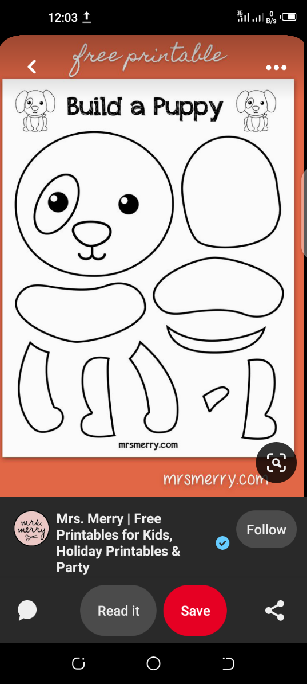  Invite learners in turns to build up the puppy using the cut outs.  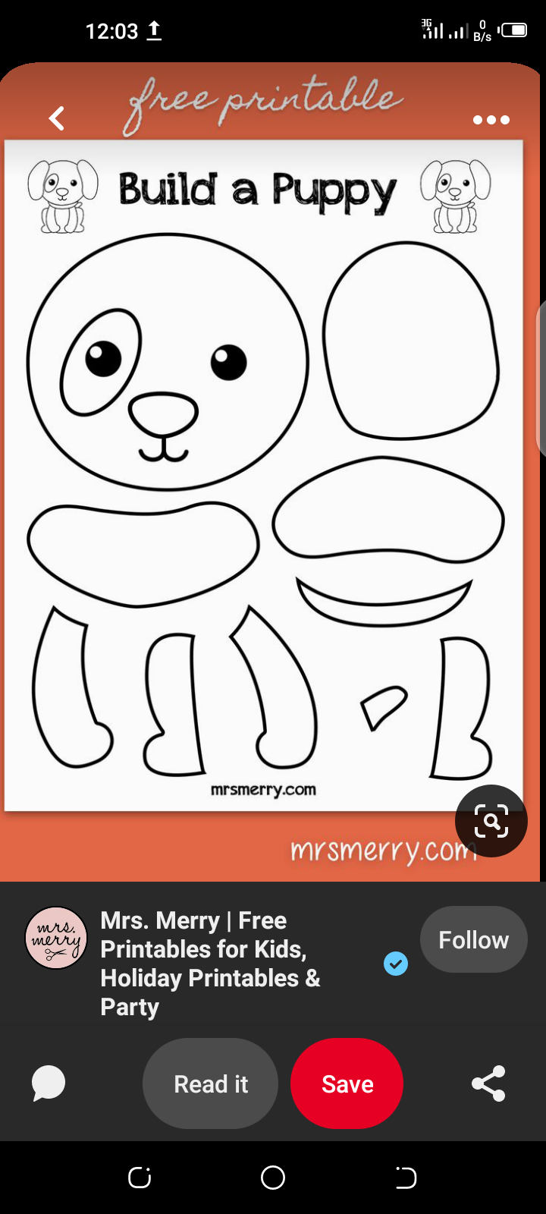  RCA QUESTION  - Did you have fun?  - What other animal would you love to build?  - Can you mention any animal in the house |  |  |  | Poster/ cut out picture depicting school/classroom gathering e.g worship, our day, Cut out shapes, big books, counters, crayons
LEARNING CENTER | Engage learners to play freely at the learning centers.  Observe, join in and ask learners questions frequently to guide their play and to support their understanding in what they are learning. |  |  |  | Word cards, letter cards.
STORY SHARING | Tell learners a story.  Pause regularly and ask questions to make sure learners are following.  Engage learners to act parts of the story.  1. Was the story interesting?  2. What part of the story did you like?  3. What have you learnt from the story? |  |  |  | Word cards, letter cards.
PHASE 3: REFLECTION | Learners share what they have learnt with their peers.  Give learners homework to do at home

SUBJECT: LANG & LIT |  | Day: TUESDAY |  | Strand: MY FAMILY
 |  |  |  | Sub Strand: MY SCHOOL FAMILY
Class: KG 2 |  | Class Size:
Content Standard:  K2.2.4 .1 Demonstrate understanding of the rules and regulations for learners and teachers at school. |  |  | Indicator:  K2.2.4.1.2 Use visual information (illustrations) and title of big book to make predictions and answer simple “wh” questions about the text  K2.2.4.1.3 Use vocabulary acquired to form sentences related to the theme
Performance Indicator:  - Learners can make predictions about books  - Learners can use vocabulary acquired to form sentences |  |  |  | Core Competencies:  Communication and collaboration, Critical thinking, Personal Development and Leadership
Keywords:
Phase/Duration | Learners Activities |  |  |  | Resources
PHASE 1: STARTER | Let learners sing a song in relation to the song.  RCA QUESTION  1. Did you enjoy the song?  2. What words did you hear in the song?
PHASE 2: NEW LEARNING  CIRCLE TIME | Sit the children in a circle, facing inwards.  One child is chosen to be “It”.  It walks around the circle, gently tapping each other player in turn on the head or shoulder, naming each player as a ‘Duck’.  When ready, it chooses one player to be the ‘Goose’ – tapping that player on the head and shout ‘Goose’.  The player selected as Goose stands up and chase It around the circle, trying to tap her before she gets all the way around the circle to sit back in the spot where the Goose was originally sitting.  If the Goose is not able to tag the It, then Goose becomes It and the game continues.
GROUP ACTIVITY 1  (OUTDOOR) | Using a narrative story related to the theme, guide learners to predict what the story will be about using the cover picture and title of the story.  E.g. Ask: What do you think is going to happen in the story? Teacher continues to read the story and let learners verify and confirm what they predicted.  Have learners listen attentively and answer “wh” questions as in the Herringbone strategy, during and after the reading,.  E.g. Who did what in the story?  What did the character do? Why?  List the new content vocabulary learnt on word cards, through consistent practice the whole week, assist learners to pronounce the words automatically and use the words meaningfully in constructing simple sentences.  One child is chosen to be Mr. (or Mrs.) Wolf. He stands a good distance (3+ meters) away from the other players with his back to them.  The other players stand side by side in a line, facing Mr. Wolf’s back. All together they call, “What’s the time, Mr. Wolf?”  Mr. Wolf responds by selecting and calling out an o’clock time (between 1 and 12).  The other players take the required number of steps towards Mr. Wolf. For example, “3 o’clock,” would mean the players take three steps towards Mr. Wolf.  These two actions are repeated resulting in the other players moving closer and closer to Mr. Wolf.  When Mr. Wolf is ready (usually when the other players are getting close), he changes his response to the question, “What’s the time, Mr. Wolf?” to “Dinnertime!”  At this cue, all of the players must turn around and race back to the starting position with Mr. Wolf chasing after them to try and catch his dinner.  The player who is caught becomes the next Mr. Wolf and the game continues.  Engage learners in their color groups to go fishing for letters.  throw some bath toys in your outdoor baby pool and let them fish for objects as you call them.  RCA QUESTIONS  - Did you have fun?  - Tell us a story you have heard before. |  |  |  | Poster/ cut out picture depicting school/classroom gathering e.g worship, our day, Cut out shapes, big books, counters, crayons
PHONICS | Engage learners to sing songs and recite some familiar rhymes that relates to the target sound.  Guide learners to pronounce and write the target sound in the sand tray or exercise books.  Have learners say three or four words that contain the target sound.  Using flash cards, learners read words that contain the target sound.  1. What sound have we learnt today?  2. Which other letter sound do you know?  3. Mention any object in the classroom or home that begins with the target letter sound. |  |  |  | Word cards, letter cards.
GROUP ACTIVITY 2  (INDOOR) | Draw up shapes on the floor with variety of colors.  Have learners hop or jump to each shape or color as you call it out.  Guide learners to write the letters on the blue and red lines in their exercise books.  For e.g. Do a rapid review of the letter sounds learnt so far.  Write both capital and lower-case letters on the Whiteboard.  Teach the sound and the key word.  Writing: practice writing the letter in the air, on their arms playfully and in their ruled writing exercise books the week.  Players arrange themselves in a circle and toss a small, round object (a tennis ball, an orange, or even a real potato will suffice) to each other while music plays.  The player who is holding the “hot potato” when the music stops is out.  The game continues until one player is left — that player is the winner.  Put learners into pairs.  Mark a start line and end line in the classroom.  Call up a pair to put their backs together. Put a balloon in there, and ask them to walk to the finish line making sure the balloon doesn’t fall off.  RCA QUESTION  - Did you have fun?  - What shapes did you learn today?  - What shape looks like a ball? |  |  |  | Poster/ cut out picture depicting school/classroom gathering e.g worship, our day, Cut out shapes, big books, counters, crayons
LEARNING CENTER | Engage learners to play freely at the learning centers.  Observe, join in and ask learners questions frequently to guide their play and to support their understanding in what they are learning. |  |  |  | Word cards, letter cards.
STORY SHARING | Tell learners a story.  Pause regularly and ask questions to make sure learners are following.  Engage learners to act parts of the story.  1. Was the story interesting?  2. What part of the story did you like?  3. What have you learnt from the story? |  |  |  | Word cards, letter cards.
PHASE 3: REFLECTION | Learners share what they have learnt with their peers.  Give learners homework to do at home

SUBJECT: LANG & LIT |  | Day: WEDNESDAY |  | Strand: MY FAMILY
 |  |  |  | Sub Strand: MY SCHOOL FAMILY
Class: KG 2 |  | Class Size:
Content Standard:  K2.2.4 .1 Demonstrate understanding of the rules and regulations for learners and teachers at school. |  |  | Indicator:  K2.2.4.1.4 Identify the letter-sound learnt for the week in words related to the theme and write the letter and key word boldly and legibly in their books.
Performance Indicator:  - Learners can identify the letter-sounds in words |  |  |  | Core Competencies:  Communication and collaboration, Critical thinking, Personal Development and Leadership
Keywords:
Phase/Duration | Learners Activities |  |  |  | Resources
PHASE 1: STARTER | Let learners sing a song in relation to the song.  RCA QUESTION  1. Did you enjoy the song?  2. What words did you hear in the song?
PHASE 2: NEW LEARNING  CIRCLE TIME | Arrange or line up empty water bottles on the floor of the classroom.  Get learners to roll a ball as best as they can towards the bottles.  Have learners count the number of bottles they knocked down and write it in the air or board.  The person who knocks down the higher number wins, and the game continues. |  |  |  | Ball
GROUP ACTIVITY 1  (OUTDOOR) | Guide learners to write the letters on the blue and red lines in their exercise books.  For e.g. Do a rapid review of the letter sounds learnt so far.  Write both capital and lower-case letters on the Whiteboard.  Teach the sound and the key word.  Writing: practice writing the letter in the air, on their arms playfully and in their ruled writing exercise books the week.  Display word cards on the teachers table in front of the class.  Group class into three or four.  Invite each leader from the group in turns to face the class with his/her back to the board.  Write a letter on the board for the others to make its sound.  The leader then search through the word cards to identify the letter.  Get about ten to twenty colored balloons. Put learners into two color groups, say red and yellow.  Now put up a big empty box at one part of the classroom as learners stands far apart facing the box.  Choose one child from the color group to participate in the race.  At the word ‘go’, they must throw the balloons (ten each) into the box facing them. The first person to finish wins.  The game continues as long as the children are having fun.  RCA QUESTION  - Did you have fun with the games?  - Would you want to play more?  - Write the letters D, H,K,M in your workbooks. |  |  |  | Poster/ cut out picture depicting school/classroom gathering e.g worship, our day, Cut out shapes, big books, counters, crayons
PHONICS | Engage learners to sing songs and recite some familiar rhymes that relates to the target sound.  Guide learners to pronounce and write the target sound in the sand tray or exercise books.  Have learners say three or four words that contain the target sound.  Using flash cards, learners read words that contain the target sound.  1. What sound have we learnt today?  2. Which other letter sound do you know?  3. Mention any object in the classroom or home that begins with the target letter sound. |  |  |  | Word cards, letter cards.
GROUP ACTIVITY 2  (INDOOR) | Children are split into teams.  Tie a cup to learners’ shoes. They are to collect colored balls from one container to another.  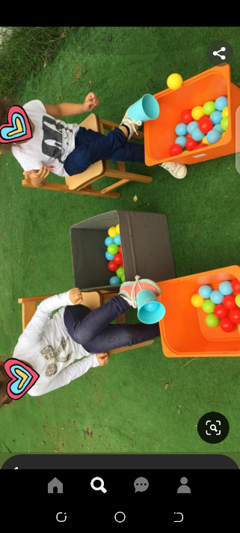  Place chairs in a line or in a circle facing out.  Lead children (more than the number of chairs available) around the chairs while singing a song.  At the end of the song, each child must sit down in the chair by which he or she is standing.  The child who remains standing is out of the game.  The last person to remain siting is the winner.  Repeat the game as long as the children are having fun.  Children are split into teams.  One from each team is chosen with a toy gun.  Teacher calls out a sound, a player must shoot their opponent by saying a word that begins /ends with that sound.  The person who shoots first wins and stays on. The loser sits down and another person from that team comes up. Whichever team has its player standing at the end wins.  RCA QUESTION  - What have we learnt today?  - Mention some of the words you learnt to a friend. |  |  |  | Poster/ cut out picture depicting school/classroom gathering e.g worship, our day, Cut out shapes, big books, counters, crayons
LEARNING CENTER | Engage learners to play freely at the learning centers.  Join in and ask learners questions frequently to guide their play. |  |  |  | Learning center
STORY SHARING | Tell learners a story.  Pause regularly and ask questions to make sure learners are following.  RCA QUESTION  1. Was the story interesting?  2. What part of the story did you like?  2. Retell the story to your partner.  4. what have you learnt from the story? |  |  |  | Word cards, letter cards.
PHASE 3: REFLECTION | Learners share what they have learnt with their peers.  Give learners homework to do at home

SUBJECT: ARTS |  | Day: THURSDAY |  | Strand: MY FAMILY
 |  |  |  | Sub Strand: MY SCHOOL FAMILY
Class: KG 2 |  | Class Size:
Content Standard:  K2.2.4 .1 Demonstrate understanding of the rules and regulations for learners and teachers at school. |  |  | Indicator:  K2.2.4.1.5 Learners can trace, color and label a picture of an object in the school which communicates rules
Performance Indicator:  - Learners can trace, color and label a picture of an object in the school which communicates rules |  |  |  | Core Competencies:  Communication and collaboration, Critical thinking, Personal Development and Leadership
Keywords:
Phase/Duration | Learners Activities |  |  |  | Resources
PHASE 1: STARTER | Let learners sing a song in relation to the song.  RCA QUESTION  1. Did you enjoy the song?  2. What words did you hear in the song?
PHASE 2: NEW LEARNING  CIRCLE TIME | Engage learners in the community circle time  Teacher gives the class a word or name and they have to make a move touching a body part for each syllable.  E.g. for the word elephant (3 syllables) the children could touch their head, then shoulders, then hips.
GROUP ACTIVITY 1  (OUTDOOR) | Ask learners: which objects give you the signal that you are late? Bell or drum.  Let learners draw and label it.  Have learners to paste their drawings on the walls of the classroom  Get about ten to twenty colored balloons. Put learners into two color groups, say red and yellow.  Now put up a big empty box at one part of the classroom as learners stands far apart facing the box.  Choose one child from the color group to participate in the race.  At the word ‘go’, they must throw the balloons (ten each) into the box facing them. The first person to finish wins.  The game continues as long as the children are having fun.  Arrange or line up empty water bottles on the floor of the classroom.  Get learners to roll a ball as best as they can towards the bottles.  Have learners count the number of bottles they knocked down and write it in the air or board.  The person who knocks down the higher number wins, and the game continues.  Players arrange themselves in a circle and toss a small, round object (a tennis ball, an orange, or even a real potato will suffice) to each other while music plays.  The player who is holding the “hot potato” when the music stops is out.  The game continues until one player is left — that player is the winner.  RCA QUESTIONS  - Did you have fun?  - Would you like to play more games?  - Learners spell bell, drums etc |  |  |  | Poster/ cut out picture depicting school/classroom gathering e.g worship, our day, Cut out shapes, big books, counters, crayons
PHONICS | Engage learners to sing songs and recite some familiar rhymes that relates to the target sound.  Guide learners to pronounce and write the target sound in the sand tray or exercise books.  Have learners say three or four words that contain the target sound.  Using flash cards, learners read words that contain the target sound.  1. What sound have we learnt today?  2. Which other letter sound do you know?  3. Mention any object in the classroom or home that begins with the target letter sound. |  |  |  | Word cards, letter cards.
GROUP ACTIVITY 2  (INDOOR) | Children are split into teams.  Tie a cup to learners’ shoes. They are to collect colored balls from one container to another.  Place chairs in a line or in a circle facing out.  Lead children (more than the number of chairs available) around the chairs while singing a song.  At the end of the song, each child must sit down in the chair by which he or she is standing.  The child who remains standing is out of the game.  The last person to remain siting is the winner.  Repeat the game as long as the children are having fun.  Children are split into teams.  One from each team is chosen with a toy gun.  Teacher calls out a sound, a player must shoot their opponent by saying a word that begins /ends with that sound.  The person who shoots first wins and stays on. The loser sits down and another person from that team comes up. Whichever team has its player standing at the end wins.  RCA QUESTION  - What have we learnt today?  - Mention some of the words you learnt to a friend. |  |  |  | Poster/ cut out picture depicting school/classroom gathering e.g worship, our day, Cut out shapes, big books, counters, crayons
LEARNING CENTER | Engage learners to play freely at the learning centers.  Observe, join in and ask learners questions frequently to guide their play and to support their understanding in what they are learning. |  |  |  | Word cards, letter cards.
STORY SHARING | Tell learners a story.  Pause regularly and ask questions to make sure learners are following.  Engage learners to act parts of the story.  1. Was the story interesting?  2. What part of the story did you like?  3. What have you learnt from the story? |  |  |  | Word cards, letter cards.
PHASE 3: REFLECTION | Learners share what they have learnt with their peers.  Give learners homework to do at home

SUBJECT: NUMERACY |  | Day: FRIDAY |  | Strand: MY FAMILY
 |  |  |  | Sub Strand: MY SCHOOL FAMILY
Class: KG 2 |  | Class Size:
Content Standard:  K2.2.4 .1 Demonstrate understanding of the rules and regulations for learners and teachers at school. |  |  | Indicator:  K2.2.2.1.6 Compare length of items and height of learners in the school using non-standard and standardized measures
Performance Indicator:  - Learners can compare length of items and height of learners in the school using non-standard and standardized measures |  |  |  | Core Competencies:  Communication and collaboration, Critical thinking, Personal Development and Leadership
Keywords:
Phase/Duration | Learners Activities |  |  |  | Resources
PHASE 1: STARTER | Engage Learners to sing songs and recite familiar rhymes  SOMETHING PASS  Something pass  Response: something pass through my body to my heart.  Something pass  Response: something pass through my mouth to my stomach.  Lalala laaa  Response: lala laa lala lala lala la  Lololo loo  Response: lolo loo lolo lolo lolo lo
PHASE 2: NEW LEARNING  CIRCLE TIME | Have your learners line up (side by side) at one end of your space facing the teacher.  The teacher stands opposite of the children and faces the children.  When the teacher shouts “Green Light!” The children walk quickly or run (depending on your space) towards the teacher.  When the teacher shouts “Red Light!” The children stop where they are.  When the teacher shouts “Yellow light”. The children must make no movement.  The teacher continues to shout “red light, yellow light or green light” until the children get to her and then all the children go back to the starting line and the game starts again |  |  |  | Colors
GROUP ACTIVITY 1  (OUTDOOR) | Scaffold learners to measure different length of spaces in the classroom and outside the classroom.  In small groups, learners use non-standardized tools such as their feet, rope or thread to measure the length of different spaces and objects in the school, tables, their classroom space, the football park, etc. and compare them using phrases such as longer than, shorter than, etc.  Using non-standardized measures, compare the heights of different learners in the class to find out who is shorter or taller than the other by having them stand side by side or back to back.  Use the phrases taller than or shorter than to describe the learners,  Get about ten to twenty colored balloons. Put learners into two color groups, say red and yellow.  Now put up a big empty box at one part of the classroom as learner’s stands far apart facing the box.  Choose one child from the color group to participate in the race.  At the word ‘go’, they must throw the balloons (ten each) into the box facing them.  The first person to finish wins.  The game continues as long as the children are having fun.  RCA QUESTIONS  - Did you have fun?  - Learners compare lengths of items in the class. |  |  |  | Poster/ cut out picture depicting school/classroom gathering e.g worship, our day, Cut out shapes, big books, counters, crayons
PHONICS | Engage learners to sing songs and recite some familiar rhymes that relates to the target sound.  Guide learners to pronounce and write the target sound in the sand tray or exercise books.  Have learners say three or four words that contain the target sound.  Using flash cards, learners read words that contain the target sound.  1. What sound have we learnt today?  2. Which other letter sound do you know?  3. Mention any object in the classroom or home that begins with the target letter sound. |  |  |  | Word cards, letter cards.
GROUP ACTIVITY 2  (INDOOR) | Assign each corner of the class with numbers or popular characters in a story.  Share numbers to learners and let everyone stand in their respective corner.  Stand in the middle of the class with a giant dice.  The teacher rolls the dice, and the number that shows up is the corner to be out.  If he rolled a five, all will sing and dance to a familiar rhyme.  If he rolled a six, everyone out will get back to their respective corners.  The last corner to remain standing in its corner wins!  Cut out a puppy and mix them up.  Invite learners in turns to build up the puppy using the cut outs.  RCA QUESTION  - Did you have fun?  - What other animal would you love to build?  - Can you mention any animal in the house |  |  |  | Poster/ cut out picture depicting school/classroom gathering e.g worship, our day, Cut out shapes, big books, counters, crayons
LEARNING CENTER | Engage learners to play freely at the learning centers.  Observe, join in and ask learners questions frequently to guide their play and to support their understanding in what they are learning. |  |  |  | Word cards, letter cards.
STORY SHARING | Tell learners a story.  Pause regularly and ask questions to make sure learners are following.  Engage learners to act parts of the story.  1. Was the story interesting?  2. What part of the story did you like?  3. What have you learnt from the story? |  |  |  | Word cards, letter cards.
PHASE 3: REFLECTION | Learners share what they have learnt with their peers.  Give learners homework to do at home

